Chapter 3 Mathematical Functions, Strings, and Objects

1.
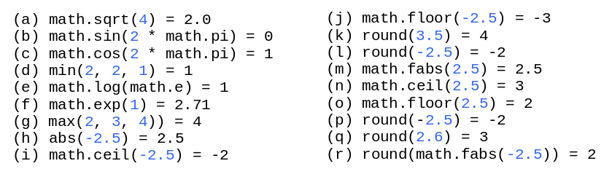

2.
True

3.
r = math.radians(47)

4.
r = math.degrees(math.pi / 7)

5.
code = ord('1')
code = ord('A')
code = ord('B')
code = ord('a')
code = ord('b')

ch = chr(40)
ch = chr(59)
ch = chr(79)
ch = chr(85)
ch = chr(90)

6.
print("\\")
print("\"")

7.
\u0078

8.
D

9.
25

10.

title = "chapter " + str(1)

11.

5
23

12.
An object is an entity such as a number, a string, a student, a desk, and a computer. Each object has an id and a type. Objects of the same kind have the same type.

You can perform operations on an object. The operations are defined using functions. The functions for the objects are called methods in Python

13.
To find the id for an object, use the id(object) function. To find the type for an object, use the type(object) function.

14.
(b)

15.
s.lower() is "\tgeorgia\n"
s.upper() is "\tGEORGIA\n"

16.
s.strip() is "Good\tMorning"

17.
The return returned from invoking the format function is a string.

18.
The width is automatically increased to accommodate the size of the actual value.

19.
57.468
12345678.9
57.40
57.40

20.

5.747e+01
1.2e+07
5.74e+01
5.74e+01

21.

5789.468
5789.468
5789.40
5789.40
5789.40

22.

45.747%
45.747%

23.

45
45
2d
2d

24.

Programming is fun
Programming is fun
Programming is fun

25.

turtle.home()

26.

turtle.dot(3, "red")

27.

Draw a square

28.

turtle.speed(number) # Set a number between 1 to 10, the larger, the faster

29.

turtle.undo()

30.

turtle.color("red")

31.

turtle.begin_fill()

turtle.color("red")
turtle.circle(40, steps = 3) # Draw a triangle
...

turtle.end_fill()

32.

turtle.hide()

